**ASSIGNMENT 06:**

You have a Jenkins master server and Jenkins slave-1

You have to create and deploy .war file on slave-1 itself, using Jenkins pipeline job.

**Step 1:** Created one Jenkins Master server, installed apache tomcat & Jenkins.

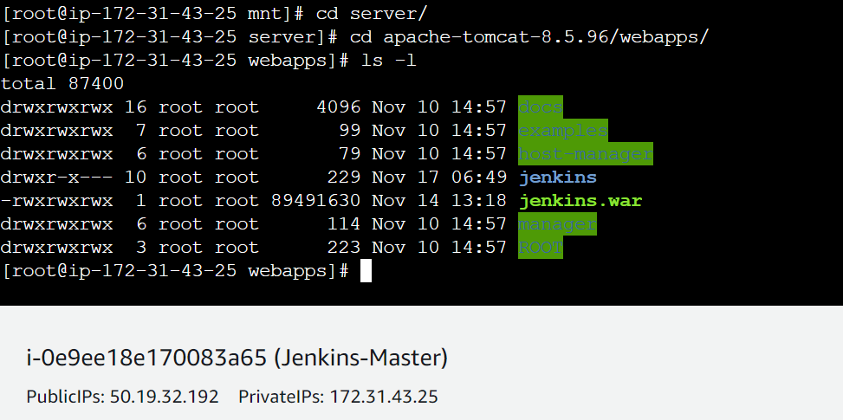

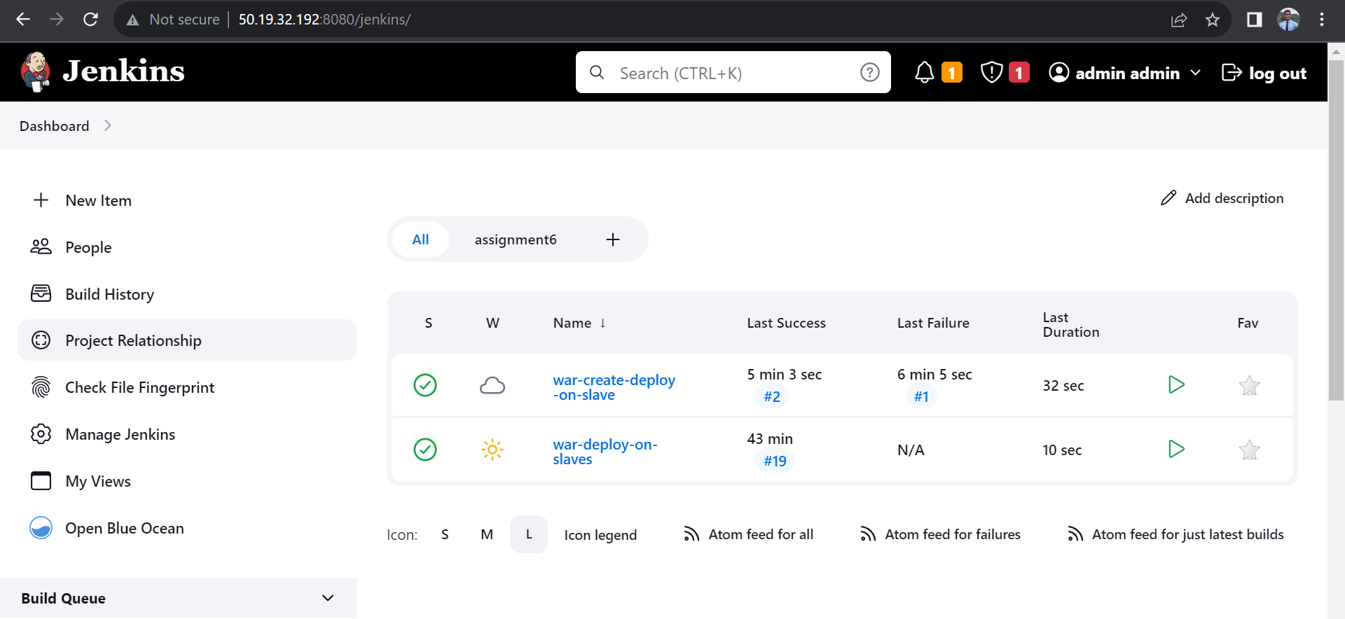

**Step 2:** Launched slave machine (slave-3) installed java, maven and apache tomcat on slave machine

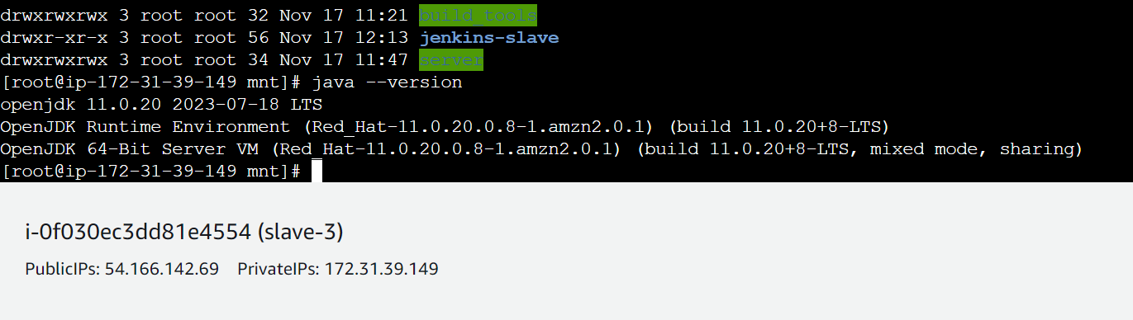

**Step 3:** Configured Jenkins Maser Slave connection using JNLP method:

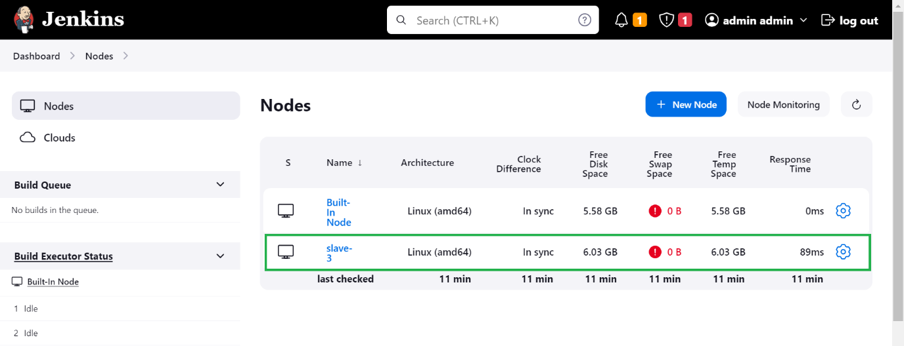

**Step 4:** Created a pipeline job:

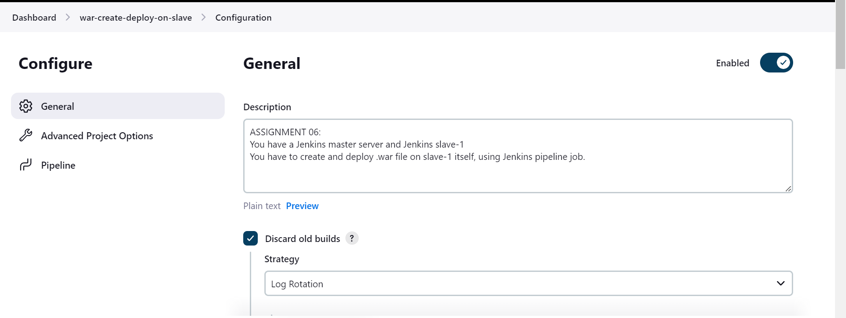

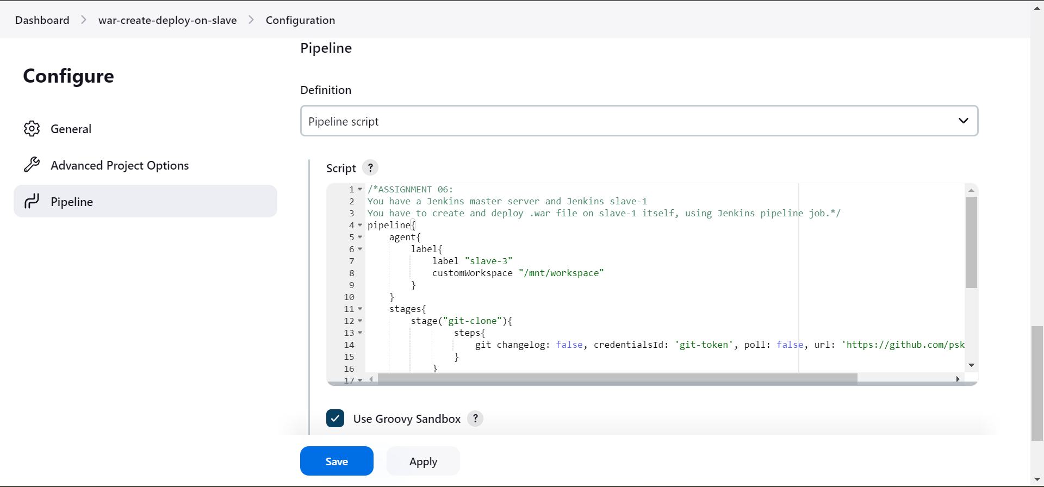

**Script that I’ve created and used for this Pipeline Job**

|  |
| --- |
| /*ASSIGNMENT 06:  You have a Jenkins master server and Jenkins slave-1  You have to create and deploy .war file on slave-1 itself, using Jenkins pipeline job.*/  pipeline{      agent{          label{              label "slave-3"              customWorkspace "/mnt/workspace"          }      }      stages{          stage("git-clone"){                  steps{                      git changelog: false, credentialsId: 'git-token', poll: false, url: 'https://github.com/pskarne/LoginWebApp.git'                  }              }          stage("mvn-build"){                  steps{                      sh "mvn clean install"                  }          }          stage("war-deploy"){              steps{                  sh "cp -r /mnt/workspace/target/LoginWebApp.war /mnt/server/apache-tomcat-8.5.96/webapps"              }          }      }  } |

**Successfully Executed Job**

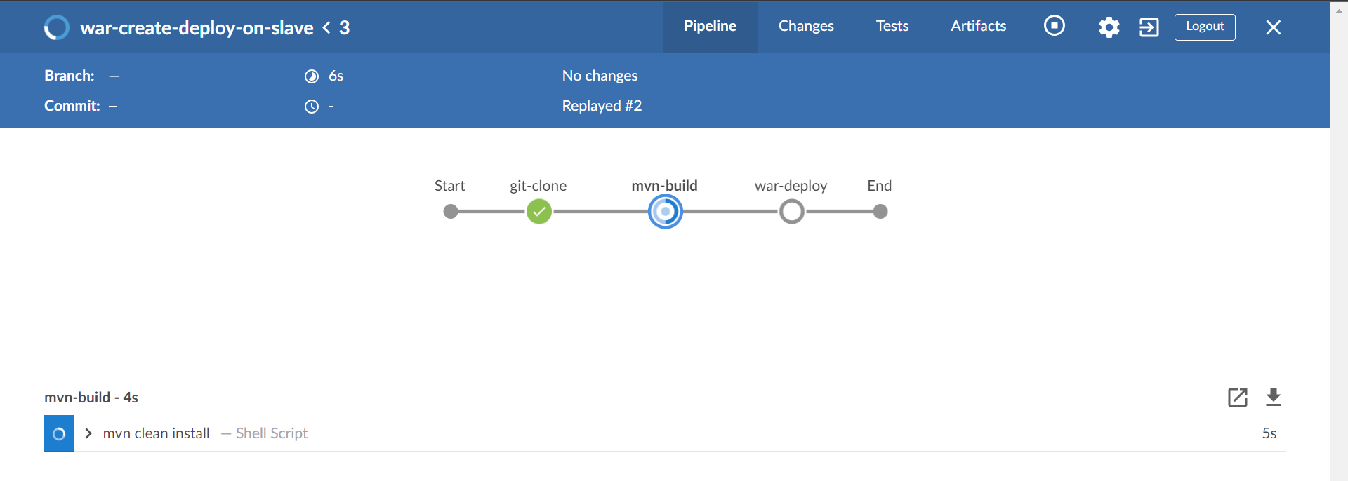

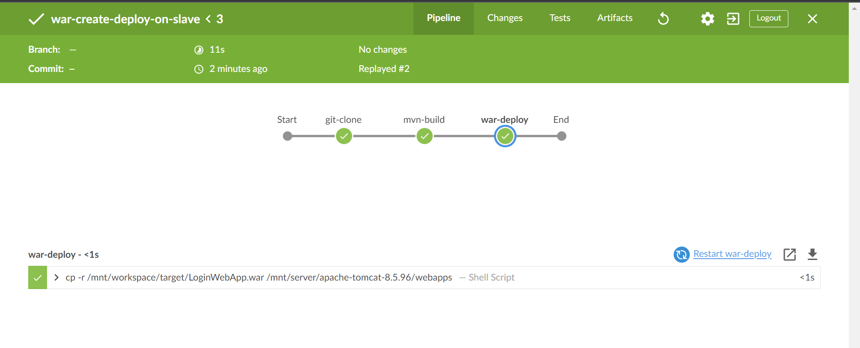

**OUTPUT**

